**LFR TRAVERSING SLIDES SERIES**

Our LFR traversing slides are made-up of following major components

1. Track roller bearings
2. Hardened & ground shafts
3. Aluminium extrusions
4. Driving elements

Track roller bearings are double row ball bearings having its outer ring thicker than inner ring. This enables it to accommodate the profile of shaft on which it rolls. These bearings are lubricated and sealed for life.

Shafts are manufactured using high carbon steel. It is induction hardened to 58-62 HRC. The shafts are hardchrome plated to prevent from rusting.

Aluminium extrusions are non-corrosive, light in weight and non-magnetic. The material is AL6063T6 grade aluminium alloy, having mechanical strength enough to be used in these slide series.

The driving elements can be

1. Timer belt & pulleys
2. Ball screws
3. Rack & pinion
4. Pneumatic/hydraulic cylinders
5. Chain & sprocket wheels etc.

The use of above components makes our traversing slides very low maintenance/maintenance free. These slides are play free. These can traverse at the highest speeds as per existing industrial requirements.

Our slides are widely used in following machines

Industrial automation, Pick & place units, Powder coating, Painting, Printing, Textiles, Wood working, Welding, Pharmaceutical, Food packaging, Tablets packaging, Cap sealing, Gas & Plasma cutting, Laser cutting etc.

Presently we have two sizes in this series LFR10 & LFR16.

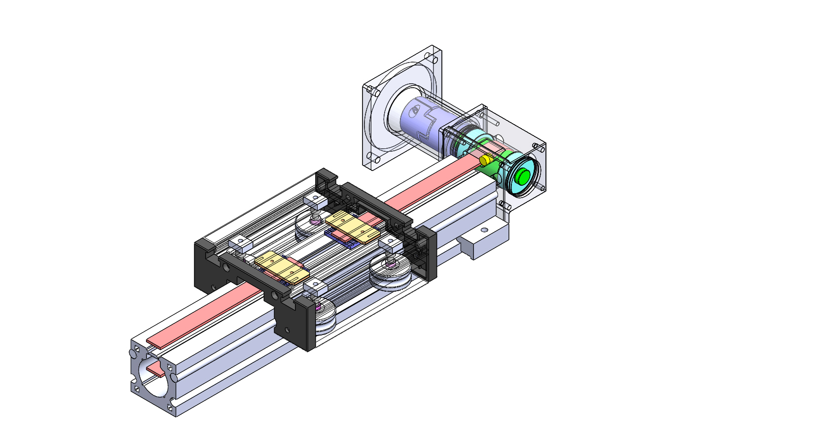f